**Name : Naga Venkata Sai**

**KLUniversity**

**CSE Btech 2nd year**

|  |  |  |
| --- | --- | --- |
| **Project ID** | **:** | **SPS_PRO_2195** |

|  |  |  |
| --- | --- | --- |
| **SBID** | : | SB20210145490 |

<https://github.com/smartinternz02/SBSPS-Challenge-5417-AI-Assisted-Farming-for-Crop-Recommendation-Farm-Yield-Prediction-Application>

**1 INTRODUCTION**

**1.1 Overview A brief description about your project**

### **AI-Assisted Farming For Crop Recommendation & Farm Yield Prediction Application**

**Category: Machine Learning**

**Skills Required:**  
**Python ,Machine Learning, IOT Cloud Platform**

**Project Description:**

**What is the problem?** Can you imagine an industry that involves more risk than agriculture? Usually, people say "**You reap what you sow**", but what they forget to add is "**if you're lucky**." When the weather strikes or cross gets affected by the disease, farmers can hardly talk about yields or when a global pandemic hits, all of a sudden it gets harder to manage various processes because most are not digital. At the same time, the global population is growing and urbanization is continuing. Disposable income is rising, and consumption habits are changing. Farmers are under a lot of pressure to meet the increasing demand, and they need a way to increase productivity. Thirty years from now, there will be more to feed, and since the amount of fertile soil is limited, there will also be a need to move beyond traditional farming. We need to look for ways to help farmers minimize their risks, or at least make them more manageable. Implementing artificial intelligence in agriculture on a global scale is one of the most promising opportunities.

**How can technology solve the problem?**

AI can potentially change the way we see agriculture, enabling farmers to achieve more results with less effort while bringing many other benefits like mentioned below

* With the help of AI, it’s possible to automate harvesting and even predict the best time for it.
* AI can simplify crop selection and help farmers identify what sort of crop will be most profitable.
* Predictive analytics can be a real game-changer. Farmers can collect and process significantly more data and do it faster with AI than they would otherwise. Analyzing market demand, forecasting prices, and determining the optimal time for sowing and harvesting are key challenges farmers can solve with AI.

**1.2 Purpose The use of this project. What can be achieved using this.**

**The Idea:**

To help farmers in minimizing the risk of agriculture we propose creating an application that recommends the farmers about the best crops to be cultivated based on climatic parameters and also predicts the yield and revenue that would be generated for cultivated land.

You can Use IBM Services to build Machine Learning models and integrate it with a User Interface

**Technical Architecture:**

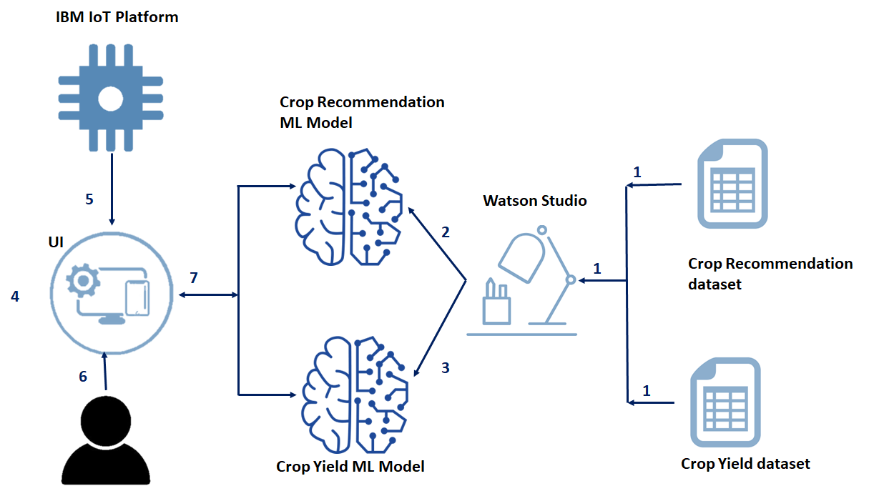

**2 LITERATURE SURVEY**

**2.1 Existing problem Existing approaches or method to solve this problem**

## Environmental factors

### Temperature effects

The most important effect of temperature is that it affects the rate at which plants develop through their stages (p 8) and produce their leaves, tillers and other components. Everything goes progressively faster as temperature rises between a base and an optimum temperature (p 81), and similarly development slows at lower temperatures. Calculating the size of these effects is discussed later (p 81). Good farm management can do more to counter the negative effects of high temperature than it can with low temperature and particularly frosts.

**Frost on a crop**

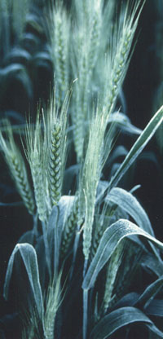

AF van Herwaarden

### Low temperature

Development slows at lower temperature. But when temperatures are low enough for frosts, severe damage is done to young tissues. Vegetative shoots can be killed below -5° C. The consequences to yield of two or more successive frosts from spike emergence (Z5.1) through anthesis into early grain filling (Z7.1) can be severe. Official Stephenson Screen temperatures (p 90) of 1.5° C measured at 1.5 metres above the ground are cold enough for effects. This temperature is equivalent to 0° C on the crop surface. A single night frost during this period may not be overwhelming because only the new tissue that has been exposed to the air during the last few days is killed. This is seen as banding of dead and live spikelets on the spikes. All tissues become more frost resistant after exposure to the air.

**Frost bands**

**Is frost or low temperature a problem?**

|  |  |
| --- | --- |
|  | Look for vegetative plants with dead shoots. Temperatures have been well below -5° C. This problem will apply only at higher latitudes and altitudes and in areas with extreme temperature changes between seasons and between day and night. A lighter coloured stripe across expanding leaves is a symptom of less severe frosts. This will generally disappear as the leaves age. However, plant photosynthesis (p 89) is reduced and growth may stop for 1-2 days after such frosts. |
|  |  |
|  | During spike emergence to grain filling, look for a band or bands around the spike (see photograph). Are the spikelets empty? Is the banding in a similar position on many spikes? Each small band is caused by one frost. |
|  |  |
|  | Look for spikes that are dark coloured, even black, without grains. This can be a consequence of sequential severe low temperatures during anthesis or early grain filling. At high altitudes in the subtropics (e.g. Nepal) sterility in spring wheat can result from 3 or more consecutive nights of non-frosting temperatures lower than 5°C between stages Z4.9 and Z5.9. |
|  |  |
|  | Are there one or two completely dead spikes on most plants but other spikes are normal? |
|  |  |
|  | Are there florets gaping open with shrivelled anthers? This may be frost damage but can be confused with boron deficit. |

**Spikes in Nepal blackened and sterile after low temperature - not frost**

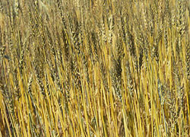

**Can you do anything about frost?**

|  |  |
| --- | --- |
|  | The only economic way to deal with frosts in wheat is to ensure that the whole crop is not at sensitive stages when frosts are most likely to occur. |
|  |  |
|  | Plant earlier or use later varieties that reach the most frost-sensitive stages (around an-thesis) when the likelihood of frost is very low. Frosts to -4° C at earlier vegetative stages are not critical to yield. |
|  |  |
|  | Plant varieties in which heading is not synchronous amongst shoots. Having spikes at different stages and different heights means that not all parts will be damaged during a single frost. |
|  |  |
|  | Plant varieties derived from winter x spring crosses that have greater cold tolerance (see Subedi et al 1998). |

**Winter temperatures well below freezing can kill vegetative growth**

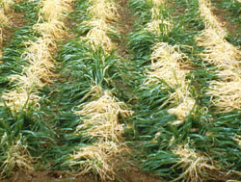

**2.2 Proposed solution What is the method or solution suggested by you?**

AI helping analyze farm data

With the help of AI, farmers can now analyze a variety of things in real time such as weather conditions, temperature, water usage or soil conditions collected from their farm to better inform their decisions. For example, AI technologies help farmers optimize planning to generate more bountiful yields by determining crop choices, the best hybrid seed choices and resource utilization.

[AI systems are also helping to improve harvest quality and accuracy](https://www.cognilytica.com/2019/04/10/ai-today-podcast-84-ai-in-agriculture-use-case-series/) -- what is known as precision agriculture. Precision agriculture uses AI technology to aid in detecting diseases in plants, pests, and poor plant nutrition on farms. AI sensors can detect and target weeds and then decide which herbicides to apply within the right buffer zone. This helps to prevent over application of herbicides and excessive toxins that find their way in our food.

**3 THEORITICAL ANALYSIS**

**3.1 Block diagram Diagrammatic overview of the project.**

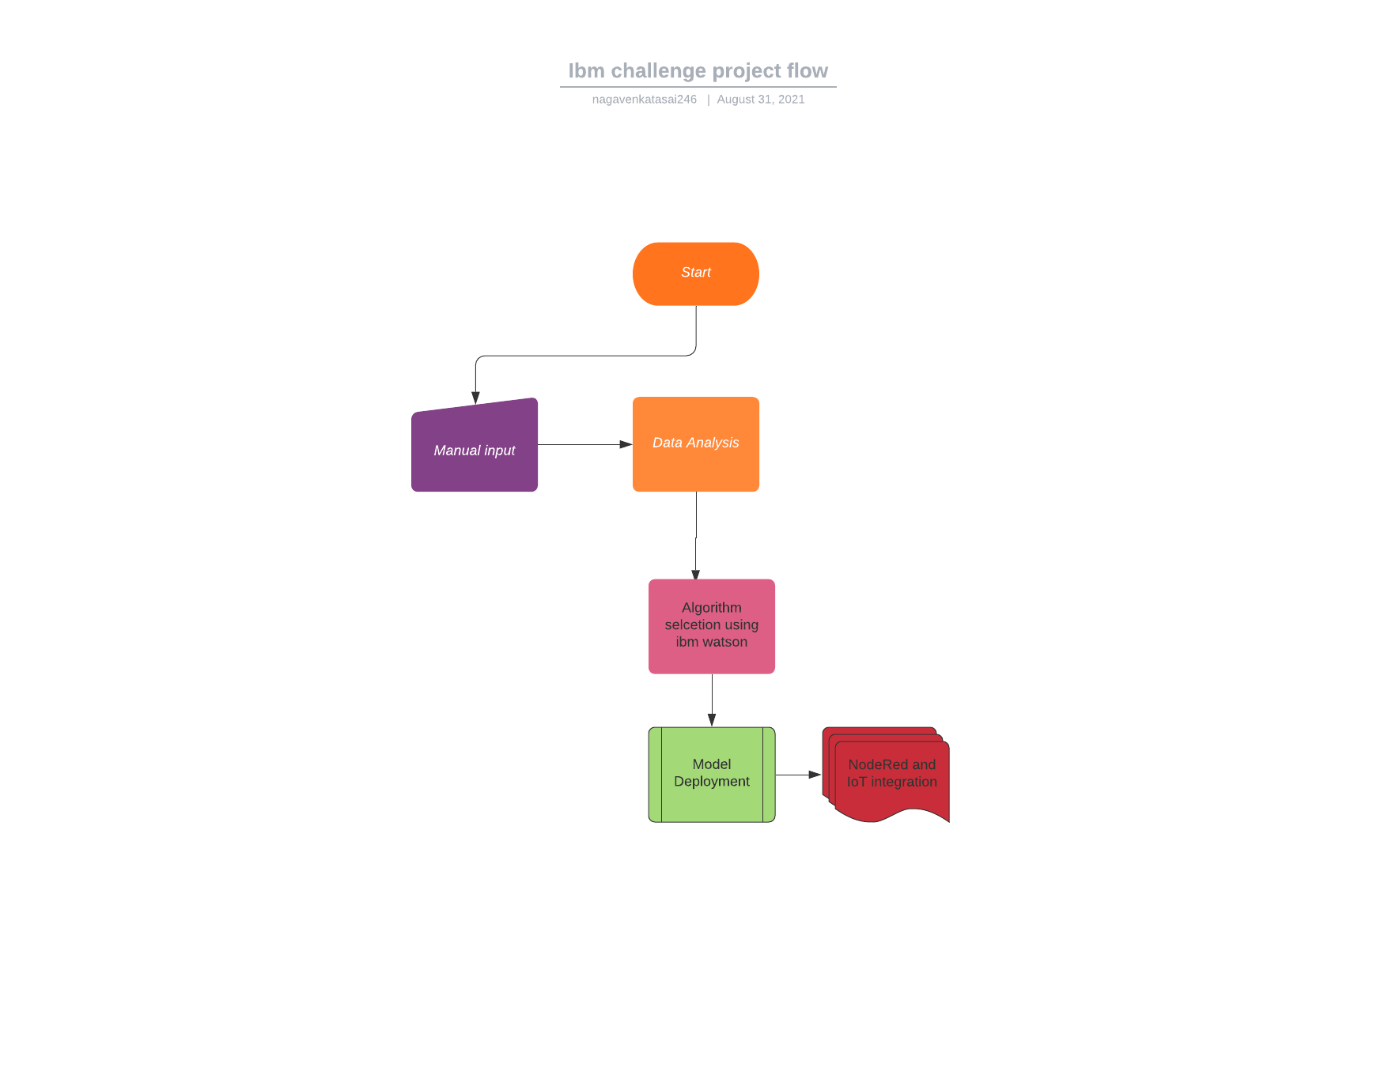

**3.2 Hardware / Software designing Hardware and software requirements of the project**

* IBM Watson Studio
* Ibm cloud Pak for data
* Ibm Machine learning(Auto Ai)
* Node Red with cloud foundry
* IBM Watson IoT Platform

**EXPERIMENTAL INVESTIGATIONS**

**Analysis or the investigation made while working on the solution.**

## **AI is the future of business. Watson is helping enterprises put AI to work.**

The Watson portfolio is designed to make it easy for you to use data from diverse sources, trust the recommendations and predictions from your AI models, and get more value from your AI, faster. With Watson, you have access to the most complete portfolio of AI capabilities for business, whether it’s tools for building your own models, pre-built applications to accelerate time to value, or access to a robust ecosystem of partners across multiple industries.

## Watson Studio, an industry leader

Watson Studio empowers you to operationalize AI anywhere as part of IBM Cloud Pak for Data. Watson Studio is named a “Leader” in *The Forrester Wave™: Multimodal Predictive Analytics and Machine Learning Q3 2020.*

[Read the report](https://www.ibm.com/account/reg/signup?formid=urx-47567)

## **Language**

## **Watson understands the language of your business.**

Valuable information often exists in forms of language that can be hard for computers to understand: PDFs. Charts. Tables. Call logs. Handwritten documents. Blog posts. News articles. Tweets. This is far too much data for a person to read, process and synthesize. But it is not too much for AI that can comprehend the language of your business. With NLP, disparate, unstructured data can be brought together and processed so you can understand what it all means and make more informed decisions. Watson can better comprehend human language, the language of your industry, and even jargon that’s specific to your company.

[Watch the Innovation Preview](https://www.ibm.com/account/reg/signup?formid=urx-43363)

75% employee time saved by using AI search

90% faster case resolution by using Watson Discovery to identify root causes and detect emerging trends

## **Trust**

## **Watson is built on an ethical foundation.**

For AI to thrive and for businesses to reap its benefits, it needs to be built on principles of trust. Watson is AI that you can understand and feel confident about because it provides the tools to help explain and manage AI-led decisions in your business. At IBM, your data and insights belong to you, and transparent processes crack open the black box of AI, giving you confidence in the technology and decisions being made. That’s confidence you can pass onto your team and your customers.

### Innovation Preview virtual event

Hear what IBM Research and Watson are doing to address trust and AI.

### AI Ethics

At IBM, we are helping people and organizations adopt AI responsibly.

[Learn more](https://www.ibm.com/artificial-intelligence/ethics)

### Trustworthy AI

Read about the key principles driving IBM’s human-centered approach to AI.

[Learn more](https://www.ibm.com/watson/trustworthy-ai)

## Women leaders in AI

IBM honors women who put AI to work across industries and around the globe. Read how these leaders put Watson’s differentiators of language, trust and automation to work.

[See the 2021 honorees](https://www.ibm.com/watson/women-leaders-in-ai)

## **Automation**

## **Watson changes how work gets done.**

The gift of automation is the gift of time. Use automation and AI across your entire enterprise — IT, customer service, risk management and more — to augment your core strengths, supplement weaknesses and empower employees. Accelerate your journey to AI with cutting-edge research. Watson, especially when integrated with the full pipeline of IBM technologies, takes a holistic approach to automation, even automating the AI lifecycle itself. As a result, Watson saves you more time and automates more processes, so that your team can focus on new opportunities, growth, or even taking some time off.

[Watch the Innovation Preview: Automation of AI](https://event.on24.com/eventRegistration/EventLobbyServlet?target=reg20.jsp&referrer=https%3A//wcc.on24.com/webcast/registration/2432185&eventid=2432185&sessionid=1&key=EFBB47ED8FE11F70D5B04D4640E1AC06) Customer wait times reduced from 8 minutes to 0 for Security First Insurance

175,000 emails a day addressed by Watson at Crédit Mutuel

90% faster maintenance research for Korean Air

Marketing model performance increased 200% for Wunderman Thompson

## **Anywhere**

## **Watson works anywhere you need it to work.**

AI is only as good as the data you use — and your organization’s data lives in multiple places in multiple formats. Watson works on any cloud, so you can break your data out of its silos without a major restructure. It’s built with open-source methods and works with open-source tools. It’s certified for Red Hat OpenShift so you can scale your AI models and applications on any cloud environment you choose, while allowing you to keep your data anywhere you want.

### Cardinal Health

Delivered a Watson-based voice agent in 5 days on a third-party cloud

[Read their story](https://www.ibm.com/blogs/journey-to-ai/2020/10/learn-how-healthcare-and-insurance-leaders-use-ai-to-strengthen-their-business)

### Streebo Inc.

Offers customized chatbot solutions with Watson and third-party APIs using IBM Cloud Pak

[Read their story](https://www.ibm.com/case-studies/streebo-cloud-watson)

### CaixaBank

Deployed a Watson-based virtual assistant on a hybrid cloud environment

[Read their story](https://newsroom.ibm.com/2020-06-04-Spains-CaixaBank-Teams-with-IBM-Services-to-Accelerate-Cloud-Transformation-and-Innovation-in-the-Financial-Services-Industry)

Watson gives more time to our client advisors.

**RESULT**

**Final findings (Output) of the project along with screenshots.**

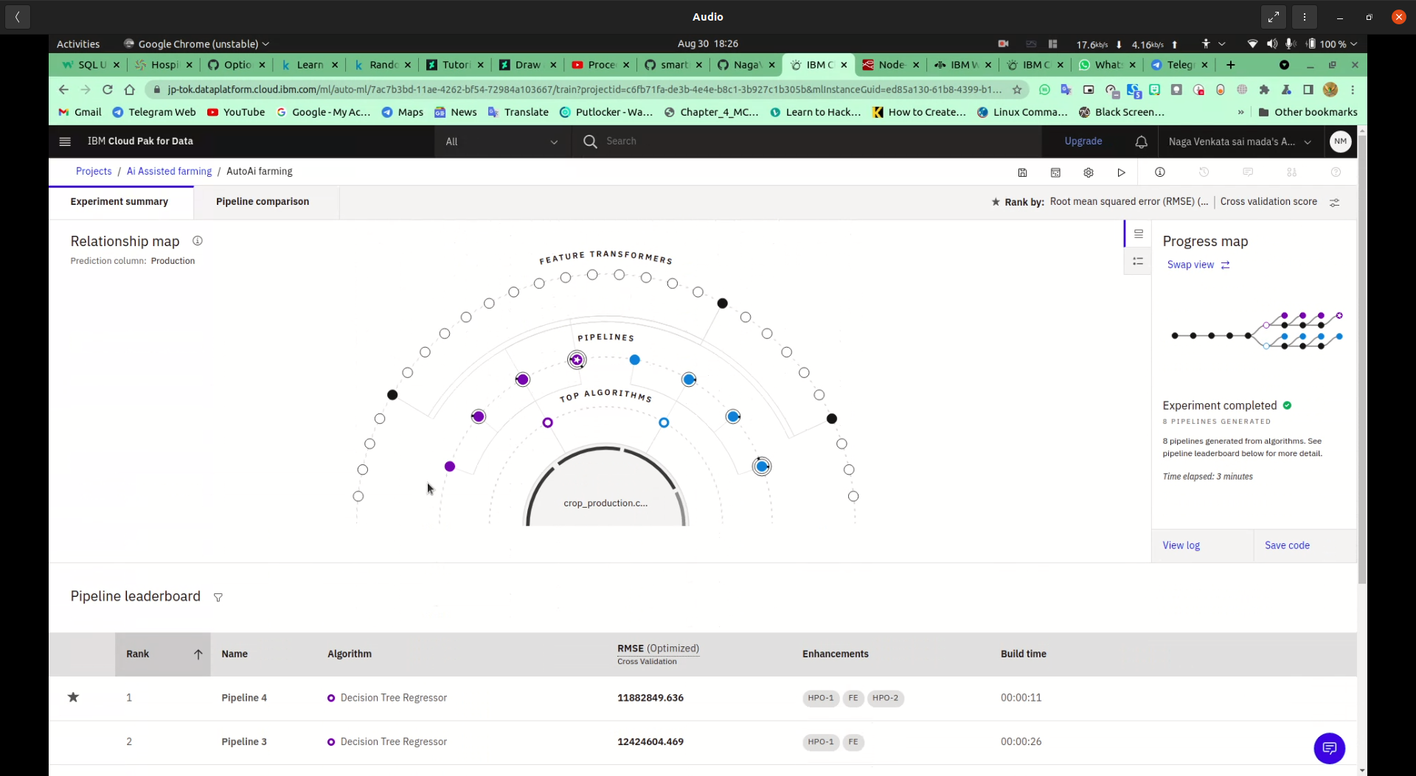

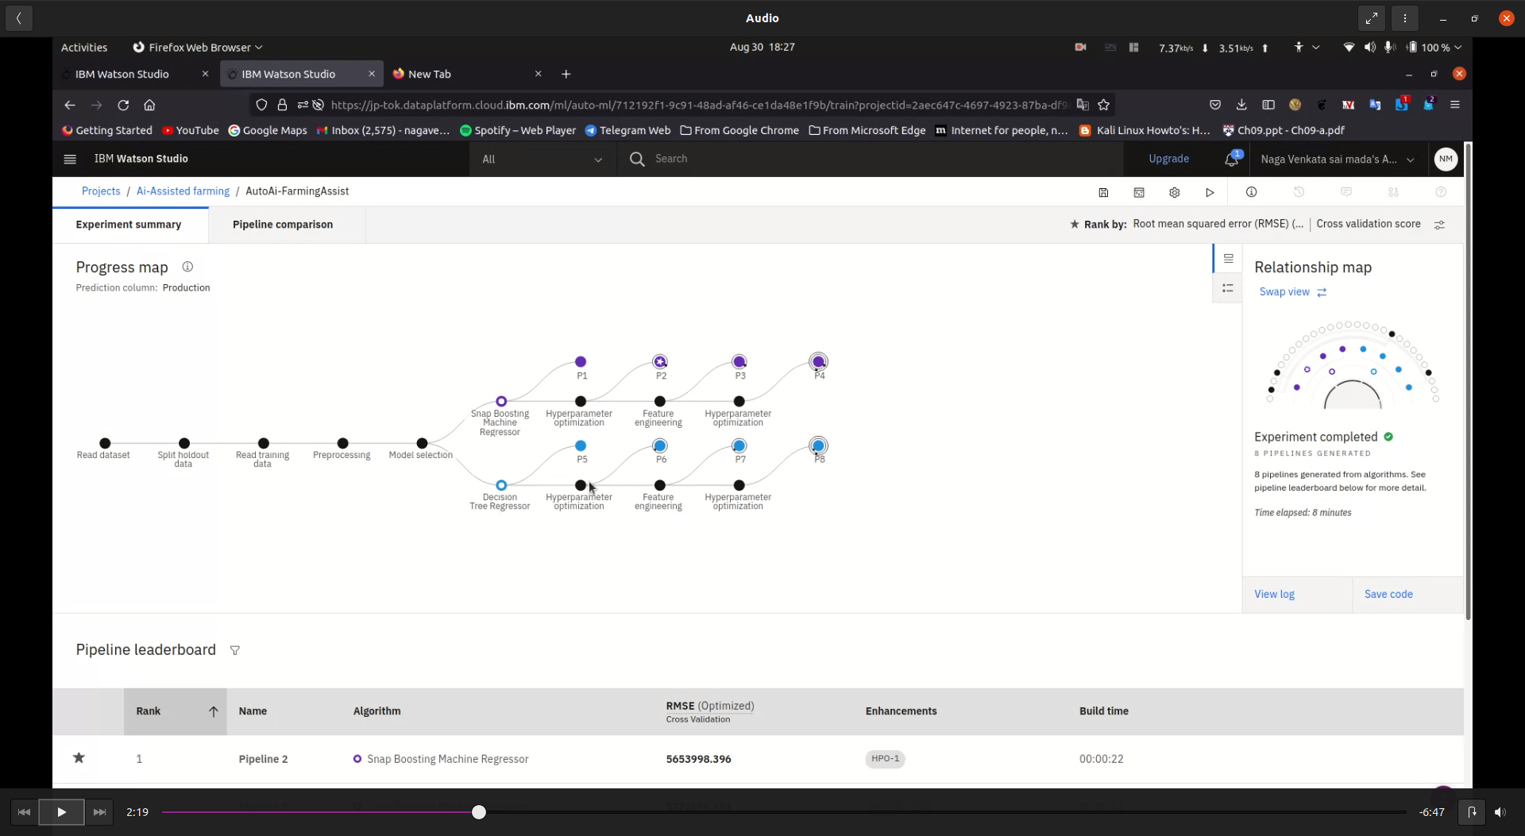

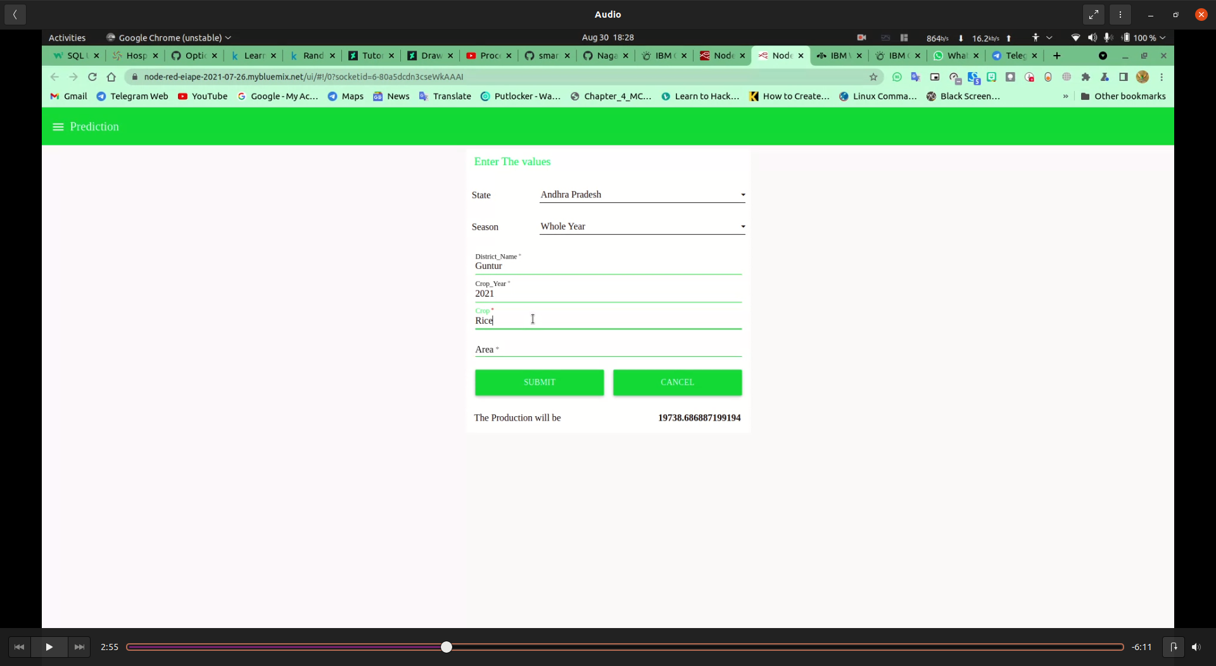

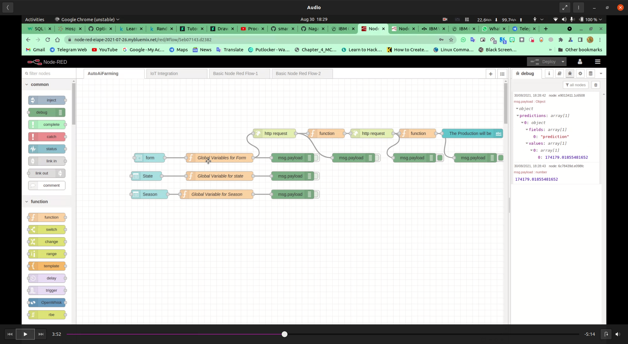

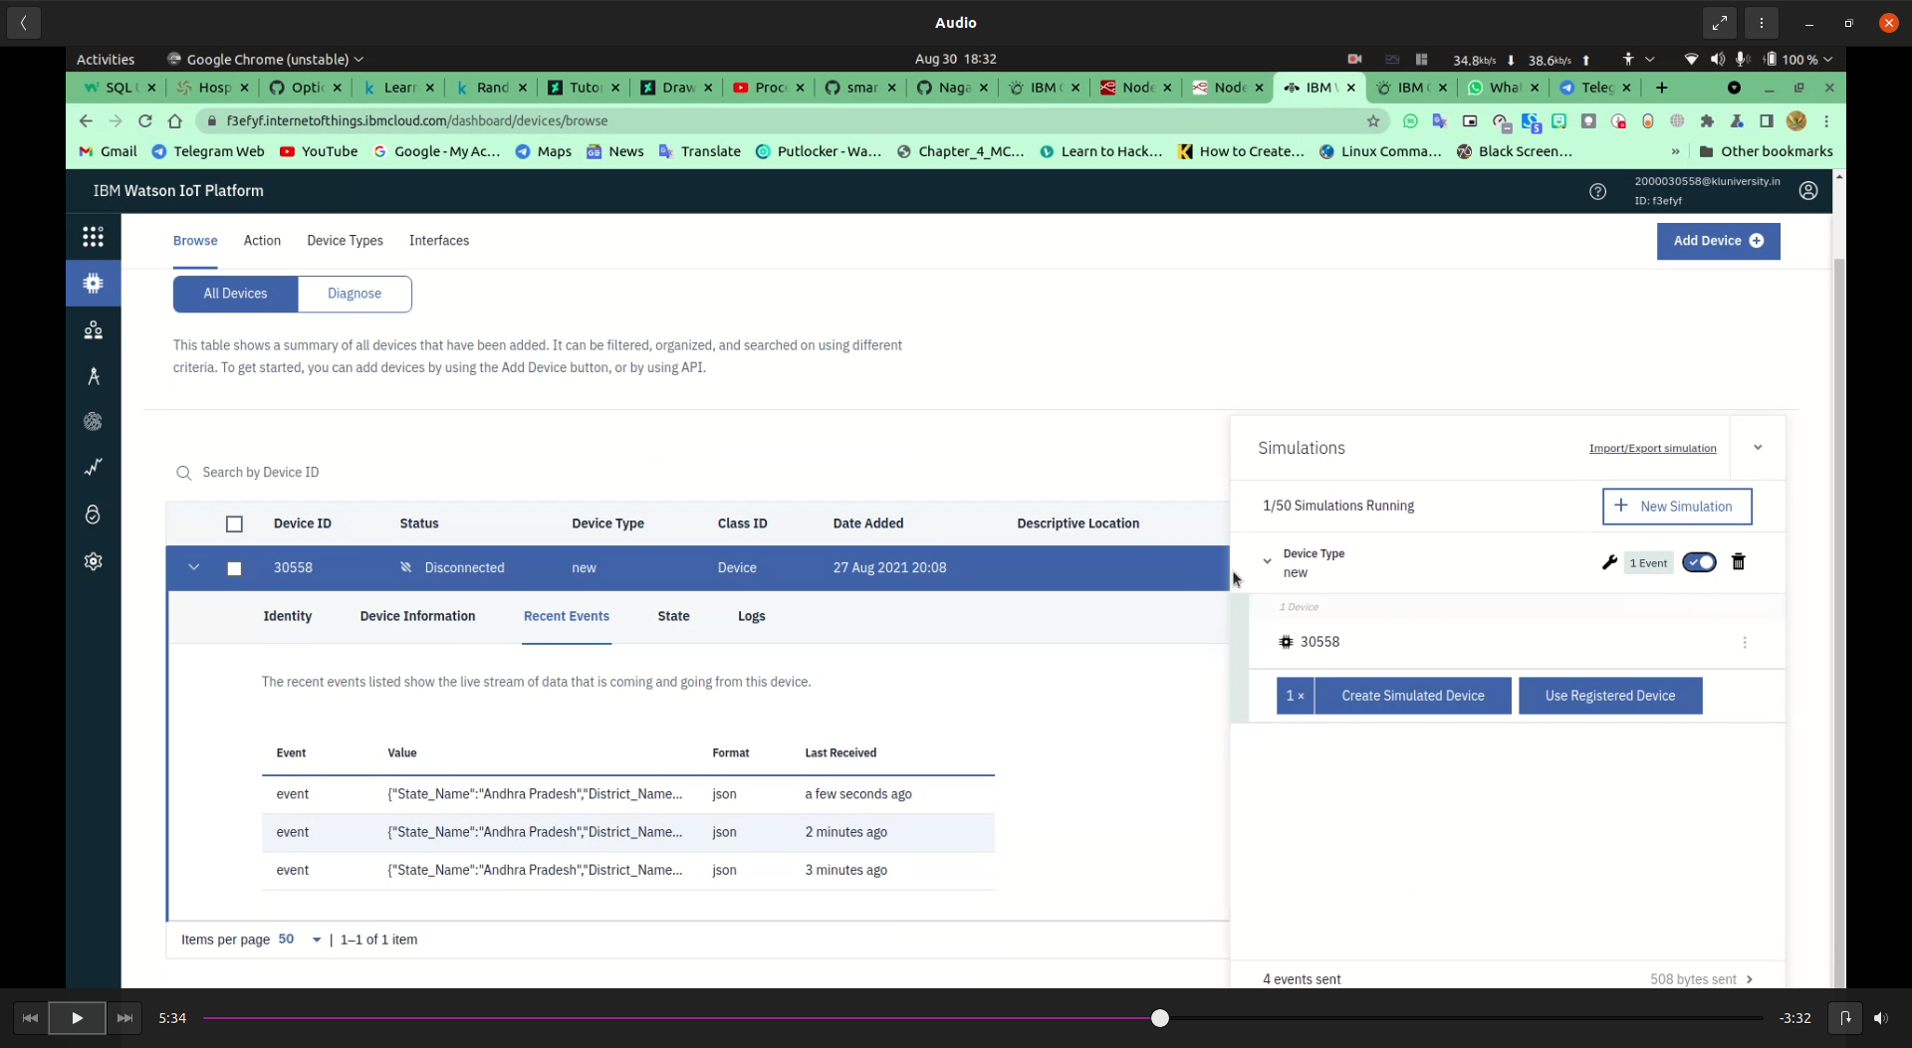

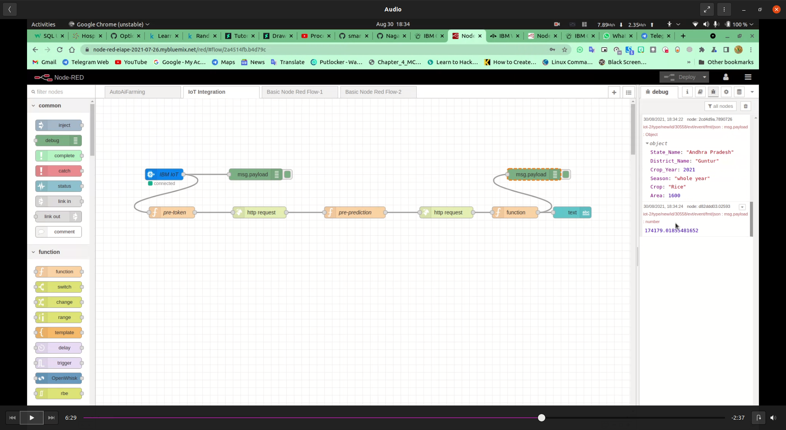

**7 ADVANTAGES & DISADVANTAGES**

**List of advantages and disadvantages of the proposed solution**

[Agriculture](https://www.online-sciences.com/robotics/applications-of-artificial-intelligence-in-agriculture-agricultural-robots-drones-plantix-app/) is becoming digital, [AI in agriculture](https://www.online-sciences.com/robotics/applications-of-artificial-intelligence-in-agriculture-agricultural-robots-drones-plantix-app/) is emerging in three major categories which are [agricultural robotics](https://www.online-sciences.com/robotics/agricultural-robots-advantages-and-disadvantages/), soil & crop monitoring, and predictive analytics, Farmers are using [sensors](https://www.online-sciences.com/technology/motion-sensors-motion-detection-features-advantages-and-how-does-the-motion-detector-work/) and soil sampling to collect data and this data is stored on-farm management systems that allow for better processing & analysis.

[Machine learning](https://www.online-sciences.com/robotics/machine-learning-overview-definition-tools-applications-cons-pros/) provides clients with a sense of their soil’s strengths and weaknesses, The emphasis is on preventing defective crops and optimizing the potential for healthy crop production, the growth in [AI technology](https://www.online-sciences.com/robotics/robotic-applications-in-agricultural-industry-autonomous-agricultural-robot-types-uses-and-importance/) has strengthened agro-based businesses to run more efficiently.

Although [Artificial intelligence](https://www.online-sciences.com/robotics/importance-of-artificial-intelligence-in-healthcare-and-medicine/) improves the [agriculture](https://www.online-sciences.com/robotics/robotic-applications-in-agricultural-industry-autonomous-agricultural-robot-types-uses-and-importance/) industry in many amazing ways, there are many concerns regarding the forthcoming of AI on employment and the workforce of the agricultural sectors, Agriculture is a $3 trillion industry that employs over 1.5 billion people, which is a whopping 20% of the world’s population, There are predictions of there being millions of unemployed field workers in the next decades primarily due to the impact of [AI](https://www.online-sciences.com/robotics/robotic-applications-in-agricultural-industry-autonomous-agricultural-robot-types-uses-and-importance/) in the agriculture industry.

**8 APPLICATIONS**

**The areas where this solution can be applied**

To help farmers in minimizing the risk of agriculture we propose creating an application that recommends the farmers about the best crops to be cultivated based on climatic parameters and also predicts the yield and revenue that would be generated for cultivated land.

**9 CONCLUSION**

**Conclusion summarizing the entire work and findings.**

**Data capture and analysis** — farms can set up setup, track and analyze a diverse set of data points thereby helping farmers make smarter decisions. This data analysis helps in arriving at much smarter approaches to the problems at hand and helps in better decision making.

**10 FUTURE SCOPE**

**Enhancements that can be made in the future.**

This project can be further improved with more data and models, A Watson assistant can be build which will help for basic queries of farmers.

**11 BIBILOGRAPHY**

**Source Code**

**Attach the code for the solution built.**

<https://github.com/smartinternz02/SBSPS-Challenge-5417-AI-Assisted-Farming-for-Crop-Recommendation-Farm-Yield-Prediction-Application>

**from ibm_watson_machine_learning.helpers import DataConnection**

**from ibm_watson_machine_learning.helpers import S3Connection, S3Location**

**training_data_reference = [**

**DataConnection(**

**connection=S3Connection(**

**api_key='Wn1mv_wiCAQLb5RNwa9dlxqq33jZuvihrkMYdR_XGSFU',**

**auth_endpoint='https://iam.bluemix.net/oidc/token/',**

**endpoint_url='https://s3.ap.cloud-object-storage.appdomain.cloud'**

**),**

**location=S3Location(**

**bucket='aiassistedfarming-donotdelete-pr-2wvfp8awhov9lh',**

**path='crop_production.csv'**

**)**

**),**

**]**

**training_result_reference = DataConnection(**

**connection=S3Connection(**

**api_key='Wn1mv_wiCAQLb5RNwa9dlxqq33jZuvihrkMYdR_XGSFU',**

**auth_endpoint='https://iam.bluemix.net/oidc/token/',**

**endpoint_url='https://s3.ap.cloud-object-storage.appdomain.cloud'**

**),**

**location=S3Location(**

**bucket='aiassistedfarming-donotdelete-pr-2wvfp8awhov9lh',**

**path='auto_ml/7ac7b3bd-11ae-4262-bf54-72984a103667/wml_data/4fc35094-932**

**d-40ce-ab77-d9540f3463ff/data/automl',**

**model_location='auto_ml/7ac7b3bd-11ae-4262-bf54-72984a103667/wml_data/4f**

**c35094-932d-40ce-ab77-d9540f3463ff/data/automl/pre_hpo_d_output/Pipeline1/model.**

**pickle',**

**training_status='auto_ml/7ac7b3bd-11ae-4262-bf54-72984a103667/wml_data/4**

**fc35094-932d-40ce-ab77-d9540f3463ff/training-status.json'**

**)**

**)**